Kickstarter is a public fundraising platform where creators share their vision online specifying the dollar amount necessary to complete the project. Donors can then contribute to the funding in either part or whole. While many projects meet or even exceed their fundraising goal, the majority do not. Using historical data, we hope to discover trends that contribute to successful campaigns.

**Description of Data**

We have been given a sample of 4,114 previous Kickstarter campaigns from 21 countries across 9 categories spanning from 2009-2017. The data source is unknown.

Quantitate Data

**Financial Goal:** Financial benchmark measure of success in currency

**Pledged Amount:** Actual amount raised in currency

**Backers Count:** The number of people who pledged any financial amount

**Percent Funded:** The percent of goal funds raised (Pledged Amount/Goal Amount)

**Average Donation:** The average amount each backer contributed to the project (Pledged Amount/ Backer Count)

Qualitative/Categorical Data

**Name:** Campaign Title

**Blurb:** Campaign description

**State:** Evaluation of campaign within four categories (successful, failed, canceled, live)

**Country:** The location of each campaign by country

**Currency:** The type of currency associated with the goal and pledge amount

**Date Created:** Date the campaign launched

**Date Ended:** Date the campaign was complete

**Spotlight:** Spotlight pages are only given to successful campaigns

**Category:** The broad topic of the project

**Sub-category:** A more specific topic of the project

**Limitations of the Data**

While the sample is sizable and diverse, there are certain pieces of information that should be recognized as missing or misleading.

* **Site Placement:** Placement on the webpage could affect visibility for potential donors
* **Creative components:** Presence, quality, and relevancy of visual components such as a cover image or video could affect campaign performance
* **Advertising efforts:** Organic site traffic is assumed for all of these, but presence of additional traffic driving support for certain campaigns is unknown
* **Donor country of origin:** While a diverse data set is good, the volume of Kickstarter campaigns varies greatly by country probing the question of popularity or even awareness of the platform in certain countries. We will assume that donors are giving globally, but certain countries that have descriptions written in languages other than English have a failed majority which begs the question—are most of the donors from English speaking countries?
* **Broad assignment:** Knowing the category, sub-category, and country could assist in more relevant results and more specific insights and recommendations

**Methodology/ Strategy**

To analyze the dataset, we will isolate and combine certain variables to glean insights.

1. First, we organized the data by campaign category using a stacked column pivot chart. This will identify the categories with the highest volume of Kickstarter campaigns launched as well as the categories that see the most success.
2. We will create a chart outlining the volume and percent successful/failed Kickstarter campaigns by country to identify countries where Kickstarter is popular and successful to focus our attention on for analysis.
3. We will create a stacked column pivot chart of subcategories to further explore optimal campaign topics.
4. We will also create a pivot table showing average backers and average backer amounts in relation to categories/sub-categories to analyze for passionate or affluent donor bases to potentially further explain category/failure or success.
5. A pivot table to compare average project goals by category could indicate optimal project budgets per category or explain if donors are more likely to give to projects with lofty goals or more attainable goals by category.
6. We will create a line chart to clearly view volume of campaigns over time as well as a line graph to view campaign states by month. This will indicate seasonal trends.

**Analysis**

What first stood out that the highest volume of Kickstarter campaigns were Theater, Music, Technology, and Film & Video and three of those were the only topics with >50% success rates.



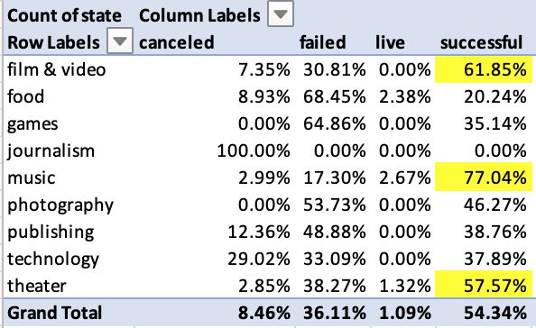

Despite data from 21 different countries, 92% of the campaigns derived from US, Great Britain and Canada.



The two countries (US and Great Britain) that make up the largest volume of campaigns (88%) also have the highest success rates, 54.34% and 60.60% respectively. Both of which are primarily English speaking.



Overall use of the platform had strong growth leading up to 2012 and peaked in 2015, maintain similar ratios of successful, cancelled, and failed campaigns in recent years.



At first glance, we see that overall February, April, and May have highest success rates and lower fail rates than other months. For campaigns later in the year, November seems to experience a spike in success rates.



We wanted to dig further to see if there was variation within the three topics with the highest success rates: Music, Film & Video, and Theater and the launch periods associated with success. Despite some nuance, it remains true February, May and November see higher success rates and lower fail rates.

* Most Music topics have seen success, aside from Faith and Jazz.
* February, June, and November show both success spikes in relation to lower fail rates, while July through October show decreased success and increased fail rates.

 

Launch Month

* In Film, Documentaries, Shorts, and Television are the only successful subcategories.
* March and November see increased success rates in relation to decreased fail rates.

 

Launch Month

* In Theater, Plays have the highest volume and highest likelihood of success (66% success rate), while Musicals and Spaces are closer to a 50% of success/failure.
* May, November, and September see increased success rates and decreased fail rates.

 

Launch Month

While it did vary some by category and subcategory, the majority average goal amount of successful campaigns was much smaller than that of the average goal of failed or cancelled campaigns.



**Conclusion**

While the context of the organizations location and specialty could allow for more specific insights and recommendations, there are several considerations to be made to help assist with a successful Kickstarter campaign. Kickstarter campaigns should be considered a viable fundraising option especially within the US or Great Britain. Outside of these countries, consider using English in the titles and descriptions to appeal to a broader donor audience on Kickstarter. Overall, you can expect a good probability of success if your campaign falls into the categories of Music (anything but Faith or Jazz), Film & Television (only Documentaries, Shorts or Television), or Theater (especially Plays). Optimal timing may vary by category, but overall February, May, or November should be months to consider a campaign launch. Lastly, try to keep the goal budget attainable, as most successful campaigns averaged lower goal amounts within the category and subcategory.

*Additional homework question: What are some other tables or graphs that we could create?*

*As shown within the report:*

* *Table to show category success and failure rates*
* *Stacked column to show success and failure rates by country*
* *Bar graph to show budget differences*